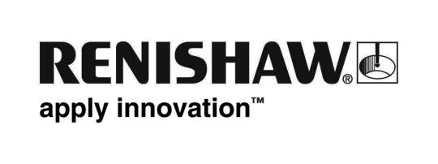

STRICT EMBARGO: NOT FOR PUBLICATION BEFORE 00.01 HOURS ON 21 APRIL 2015

Renishaw wins a Queen’s Award for Enterprise: Innovation 2015 for revolutionary absolute position encoder

A Queen’s Award for Enterprise 2015 in the Innovation category has been granted to Renishaw for the development and manufacture of its RESOLUTE™ family of non-contact, optical position feedback devices. RESOLUTE enables a step change in the performance of motion control systems used in manufacturing and other environments. The global engineering technologies company is delighted to have won its eighteenth Queen’s Award in the 50th anniversary year of this prestigious awards scheme.

Suitable for the most demanding applications, RESOLUTE is the world’s first single track fine-pitch optical absolute encoder. It can determine position to a resolution of one nanometre (one billionth of a metre) with motion speeds of up to 100 metres per second for linear position applications, and is capable of 32-bit resolution at up to 36,000 RPM for rotary (angle) applications. It determines position immediately at switch-on and is compatible with a range of ‘open’ and ‘proprietary’ serial protocols including Siemens DRIVE-CLIQ, BiSS®, FANUC, Mitsubishi and Panasonic.

Sir David McMurtry, Renishaw’s Chairman and Chief Executive, said: “RESOLUTE is a phenomenal product that marries our years of experience and expertise in areas such as optics, high speed image processing, system engineering and precision manufacturing. I am proud of the achievements of the many people across the Renishaw Group who have worked tirelessly to produce a globally successful encoder product that is a world-first in its field.”

He continued: “We won our first Queen’s Award in 1979 for Export Achievement, and whilst we have been fortunate to have been recognised a further seventeen times over the years, to receive a Queen’s Award is still very special as they continue to be regarded as the UK’s most prestigious awards for recognising commercial and technological success.”

RESOLUTE is employed in a diverse variety of applications including safety-critical position feedback for medical robots, the control of precision metalworking machines, the manufacture of flat panel displays and the production of semiconductors.

The Queen’s Awards for Enterprise are made each year by Her Majesty The Queen, on the advice of the British Prime Minister, who is assisted by an Advisory Committee that includes representatives of Government, industry and commerce, and the trade unions. The Awards are given solely on merit and competition is fierce. The number of Awards presented each year is not pre-set and depends on the quality of the applications received.
-Ends-
About Renishaw
Renishaw is one of the world's leading engineering and scientific technology companies, with expertise in precision measurement and healthcare. The company supplies products for use in applications as diverse as jet engine and wind turbine manufacture, through to dentistry and brain surgery. It is also a world leader in the field of additive manufacturing (also referred to as 3D printing), where it is the only UK business that designs and makes industrial machines which ‘print’ parts from metal powder.
The Renishaw Group currently has more than 70 offices in 32 countries, with over 3,800 employees, of which 2,500 people are employed within the UK, primarily in South Wales (near Cardiff) and Gloucestershire (five sites). The majority of the company’s R&D and manufacturing is carried out in the UK and for the year ended June 2014 Renishaw recorded sales of £355.5 million of which 93% was due to exports. The company’s largest markets are the USA, China, Germany and Japan.

