4th March 2016

Renishaw launches the new inVia™ Qontor™ confocal Raman microscope

The new inVia Qontor is Renishaw’s most advanced Raman microscope. Building on the market-leading inVia Reflex, the inVia Qontor adds a new dimension to the performance and ease of use for which inVia is renowned.

The inVia Qontor sees the addition of Renishaw’s latest innovation, LiveTrack™ focus tracking technology, which enables users to analyse samples with uneven, curved or rough surfaces. Optimum focus is maintained in real time during data collection and white light video viewing. This removes the need for time consuming manual focusing, pre-scanning or sample preparation.

The inVia Qontor, equipped with LiveTrack, enables the acquisition of accurate and reproducible spectra from samples with extensive topographic variations. Because a sample’s topography no longer limits Raman imaging capability, LiveTrack opens up the analysis of a whole new range of samples and applications.

With LiveTrack, focusing is dynamic. LiveTrack provides continuous feedback to the sample stage which adjusts to follow the height of the sample. This ensures the laser maintains focus during data collection and when manually moving the sample during white light video viewing. Optimum focus is maintained across uneven, sloping or dynamic samples, limited only by the maximum travel of the stage.

The inVia Qontor enables the analysis of samples that were previously impractical to study, or would have required extensive sample preparation. For example, uneven geological samples that normally require sectioning and polishing can now be analysed without any sample preparation.

Tim Smith, Renishaw Applications Scientist, said: “Acquiring in-focus Raman images of your whole sample is now a reality. Users can track the surface live while acquiring surface or even subsurface Raman data and later view the Raman image and surface topography of their sample in 3D. This innovation not only saves time but, in some cases, allows us to analyse samples that were previously impossible to study.”

The inVia range of microscopes is trusted worldwide to deliver outstanding performance and reliable results, for even the most challenging experiments. The inVia Qontor Raman microscope’s cutting-edge technology reduces overall experiment times and makes analysing even the most complex samples easy.

To find out more information, visit www.renishaw.com/go/Qontor
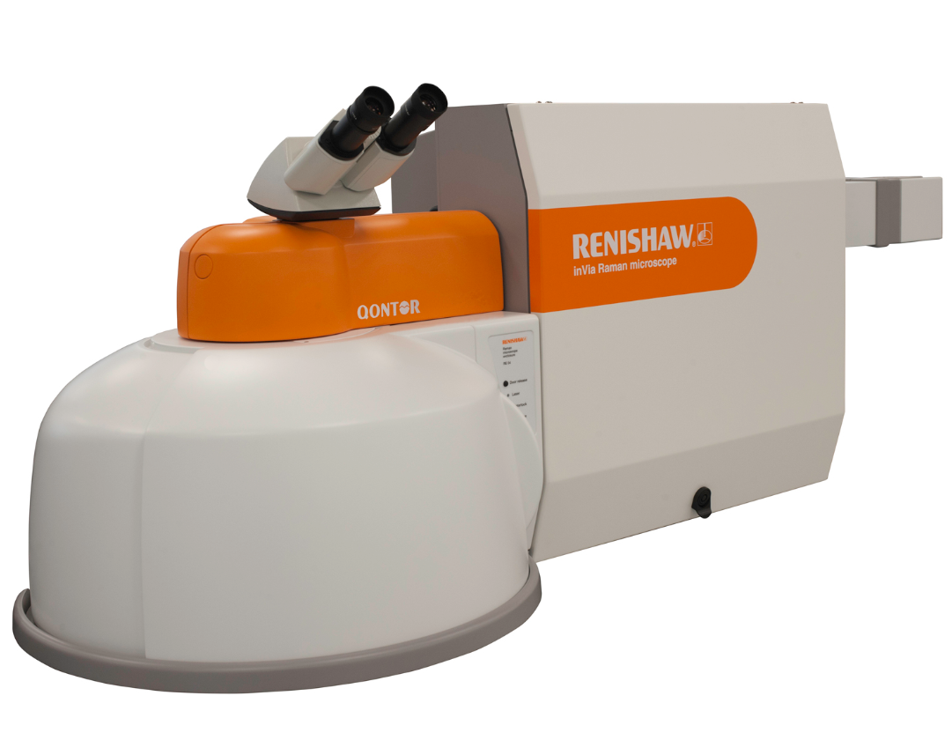

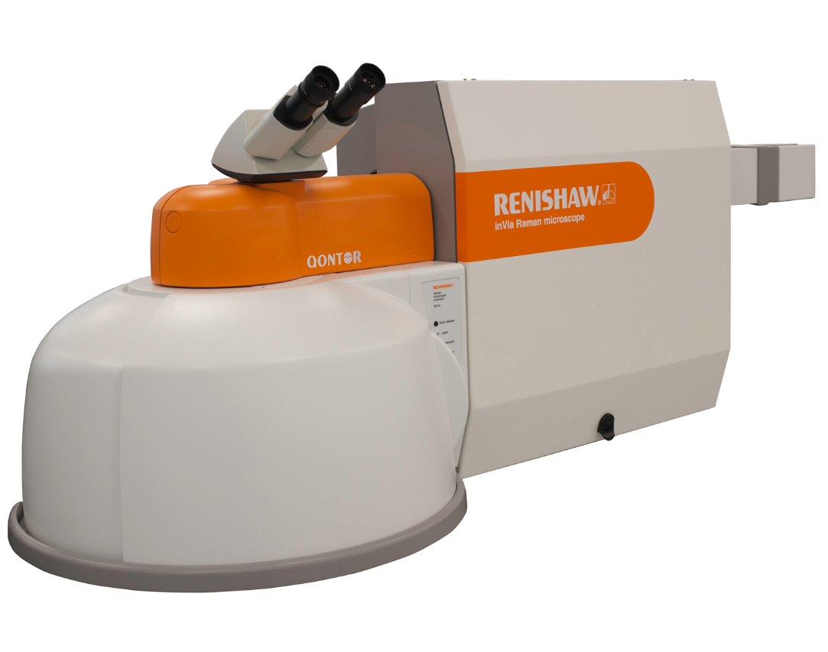

Image: Renishaw’s inVia Qontor Raman microscope.
-Ends-
About Renishaw
Renishaw is one of the world's leading engineering and scientific technology companies, with expertise in precision measurement and healthcare. The company supplies products and services used in applications as diverse as jet engine and wind turbine manufacture, through to dentistry and brain surgery. It is also a world leader in the field of additive manufacturing (also referred to as 3D printing), where it is the only UK business that designs and makes industrial machines which ‘print' parts from metal powder.
The Renishaw Group currently has more than 70 offices in 33 countries, with over 4,000 employees, of which 2,700 people are employed within the UK. The majority of the company's R&D and manufacturing is carried out in the UK and for the year ended June 2015 Renishaw achieved sales of £494.7 million of which 95% was due to exports. The company's largest markets are the USA, China, South Korea, Germany and Japan.
The Company's success has been recognised with numerous international awards, including eighteen Queen's Awards recognising achievements in technology, export and innovation. Renishaw received a Queen’s Award for Enterprise 2014, in the Innovations category, for the continuous development of the inVia confocal Raman microscope. For more information visit www.renishaw.com

For further information
Please contact:
David Reece
Renishaw plc
New Mills
Wotton-under-Edge
Gloucestershire GL12 8JR UK
Tel: +44 1453 523968 (direct)
Tel: +44 1453 524524 (switchboard)
Fax: +44 1453 523901
Email: david.reece@renishaw.com
www.renishaw.com/raman

